Bike Bus Leader Training

Awesome that you’ve put your hand up to help lead a school bike bus! You should be a confident rider and keen to help teach the children some safe riding practices.

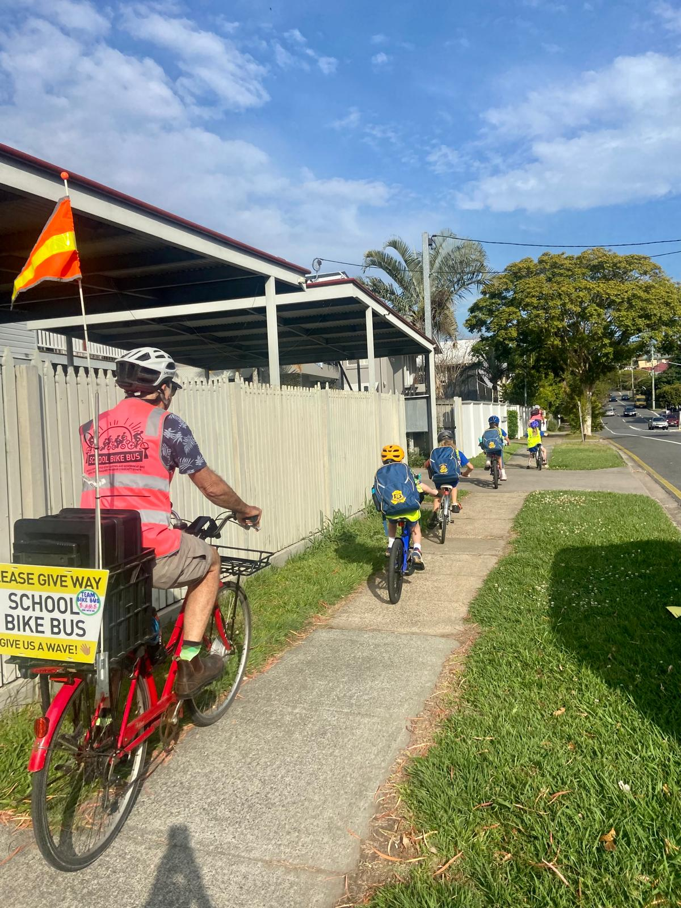

There are a few tips we’ve compiled to help get you on the way. A good riding ratio is one adult to every three to four children. With the leader (bus driver!) at the front and another adult at the back to ensure no one is left alone.

What’s a School Bike Bus?
A bike bus is a group of people riding together long a set route at a set time, picking up cyclists as they go along either at designated stops or anywhere that’s convenient for them along the road. For a school bike bus, this will be a group of children led by adult riders escorting them from their home to school. The adult leaders could be parents, teachers or other community volunteers.
A school bike bus is a way of safely introducing children to cycling, helping them to develop confidence riding on the streets and have healthy fun on the way to school.
Who can lead a bike bus?
To lead a school bike bus you should:
- Be able to ride a bike
- Be able to get on with children
- Have a Working with Children check (Blue Card) if you do not have children taking part in the Bike Bus (parents and carers are exempt from this).
That’s it. Leading a Bike Bus is pretty easy and doesn’t require any special skills.

Ground Rules:
It’s important to set some ground rules with the children when they join the bike bus.
- Leader rides at the front and no one should ride in front of them
- Listen to leader & follow road rules (stop / give way signs etc)
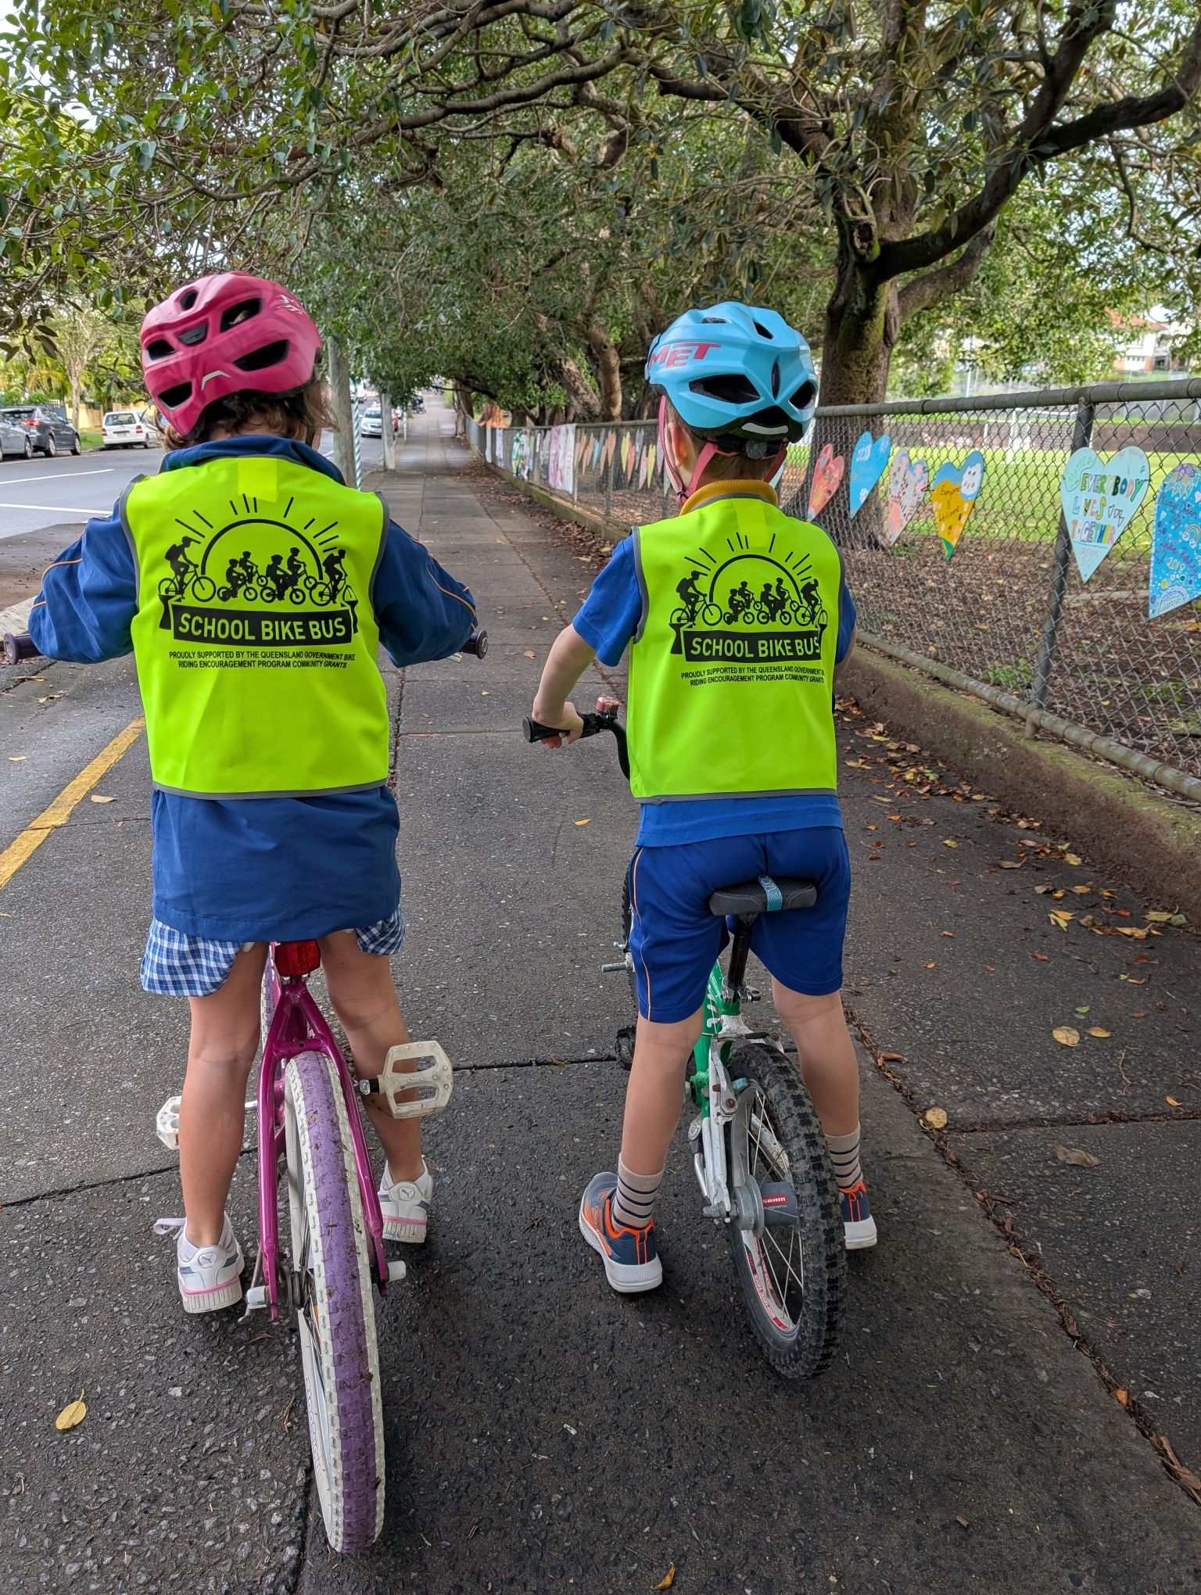
- Riding two abreast is okay on the road (adults on the right to stop kids moving towards oncoming traffic)

Equipment Recommended:
- High vis safety vests for all riders
- First aid kit or at least a few bandaids and dressings
- Some basic tools – a multi-tool is probably all you need, in case someone needs quick repairs on their bike
- Speaker for music - this makes it way more fun for the kids!
- Give way sign for the leader’s bike or safety flag for improved visibility
- All kids should have a properly fitting helmet and working bell

Leader Roles
With a group of children, it helps to have at least 2 adults who know what they’re doing – more can be helpful, especially for a larger group.
- One would go at the front of the ride to lead the way along the route and set the pace. The front rider should be careful not to go too fast, so slower kids can’t keep up – you might need to get some of the more confident kids to slow down! You need to make sure you keep an eye out for who is behind you, so you don’t get too far ahead and so you can stop and wait if someone gets held up at the back
- The other would go at the back. This person will ensure that the group stays together and stays to the left if they are on the road, and particularly take care of any kids who aren’t confident riders. Feel free to yell out to the person at the front if they are going too fast!
- If you have extra helpers/parents, they can ride among the kids – generally have the kids to the left and the adults to the right to stop the kids straying across the road.

Picking Up Passengers
You mostly pick up passengers at designated stopping points like a bus does, but these can be variable. If a child lives directly on the route, their home could be a stopping point. If they live near the route but not actually on it, they would make their own way to their nearest stopping point. In reality, you can pick up at any point on the route and there’s no reason you can’t vary the route a little to pass someone’s home if that makes it easier to pick them up.

A Welcoming, Friendly Atmosphere
A bike bus should be fun for everyone involved.
- Welcome children and parents when they join the ride each time
- Encourage the children as they ride
- If they do something silly, like racing ahead, gently remind them of what they should do

Different Ability Levels
You are likely to have some children who are very confident riders and some who are just learning. Your normal age range would start at 7/8 and go all the way up to 11 – there’s no formal age limit, they just need to be able to keep the bike upright.
1. If you have kids who are still learning to ride but want to join in, it’s best if they have a parent/carer with them to help them out. We’ve had a young child ride the whole way with mum holding the bike seat to keep it upright. In our experience, kids at this point learn fast and before long they can ride confidently – it’s great to praise them for their improvement!
2. We’ve also had some children join on scooters. This is fine if they join close to the school, but over longer distances or up steep hills they can really struggle to keep up, especially on little toy scooters with tiny wheels. Use your discretion on this one – we tend to let them join wherever possible as inclusion is the aim, but you might need to advise the parents it’s not practical at times.
3. On the other end, you will get some children who are very confident riders. The main thing that can sometimes be challenging with them is to stop them going too fast and leaving the younger or less confident children behind. It helps to set up the rule at the start that children ride behind the front leader (who then sets the pace, and also prevents them crossing roads unsafely) and if they get impatient, to remind them not to outpace the younger ones.

Crossing the Road
Crossings can be tricky with a group of children. Generally the route will be planned to only cross major roads at traffic lights and wherever possible other busy roads at zebra crossings. Where there’s none available (all too common here in Brisbane!) having two leaders enables you to occupy each lane of a two-lane road to block any oncoming traffic while the children cross, as shown in the diagram below.
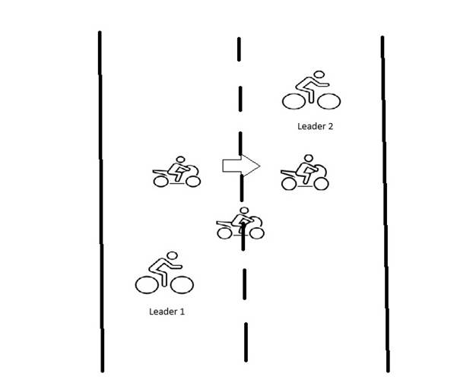
1. Wait until the road is clear of traffic.
2. Both leaders move into place as shown.
3. Children (and any other adults) cross between the two leaders.
4. Leaders complete the crossing after all the children are safely across.
Remember that a compact bike bus is the most effective way to cross a road as the group is more visible and quicker through the intersection.
Keep the communication clear with the kids as to when they can stop and go etc.

Other Tips
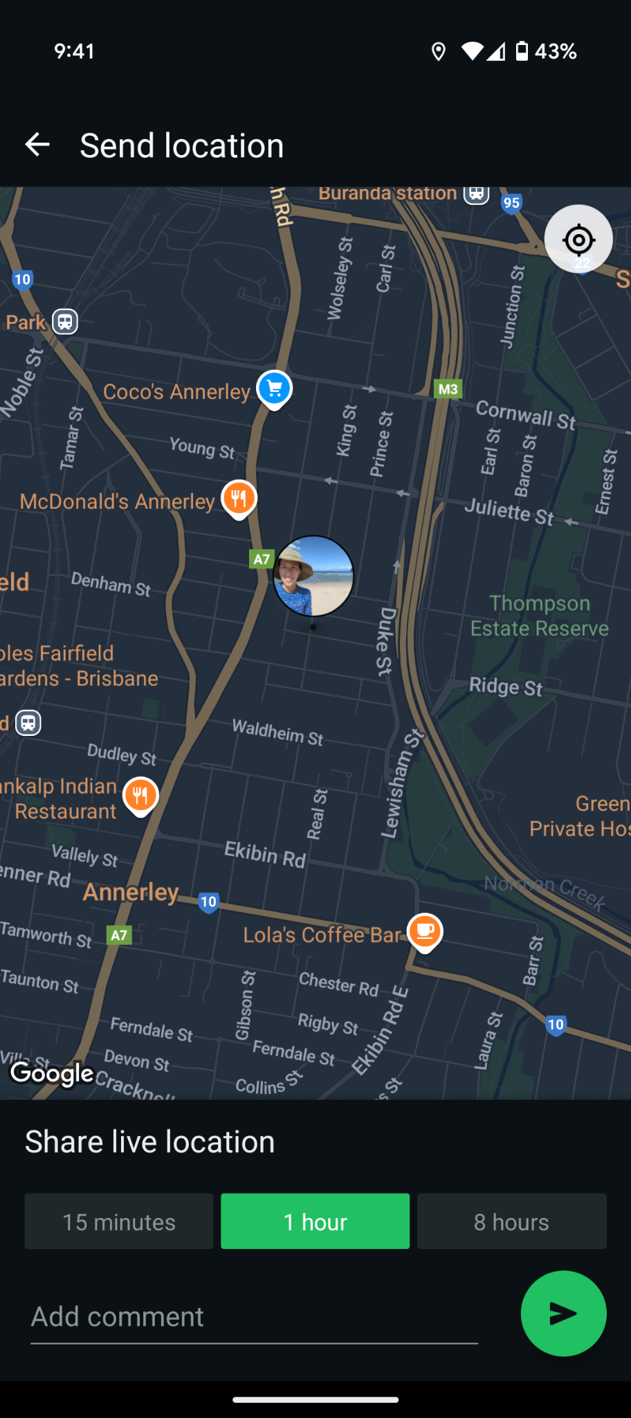
Make sure you know your route well and consider where / when you might ride from footpath to road and visa versa. There may be some footpaths or roads where the camber isn’t the easiest for children to start or stop on their bikes.

Communication / Live Location
Let your route know when you’re leaving, if the group uses WhatsApp, the route leader can share their live location so that families can see when the bike bus is arriving. Click the paperclip icon when you go to send a message, click on “Location” then ‘Share live location” and select the duration.

