Bike Bus Program - Overview

The Bike Bus Program has been up and running since the end of May 2025 at Junction Park State School and the start of June 2025 at Yeronga State School. Dutton Park State school started in mid July 2025. This has been a program proudly supported by the Queensland Government Bike Riding Encouragement Program Community Grants.
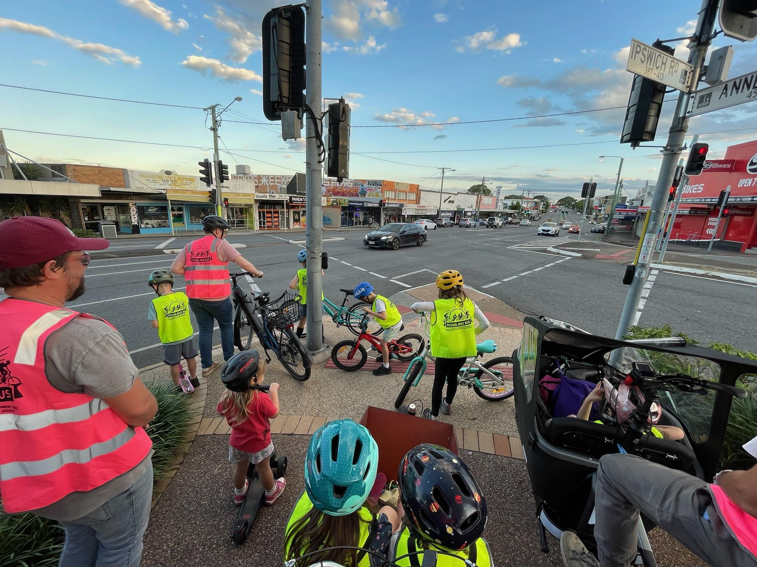

The Process
The grant recipient team got together to brainstorm the process of getting the bike buses up and running. We decided to create a survey to find out if families ride to school (or why not), if they would be interested in joining a school bike bus, scope out possible route leaders and collect information about where people ride from.

Initial survey can be found here for reference: https://forms.gle/PNhA2KzAAarVYxMY8

Each route to school was determined by gathering information from students and parents about where they ride to school. We used the initial survey and National Ride to School Day in March to capture data from families.
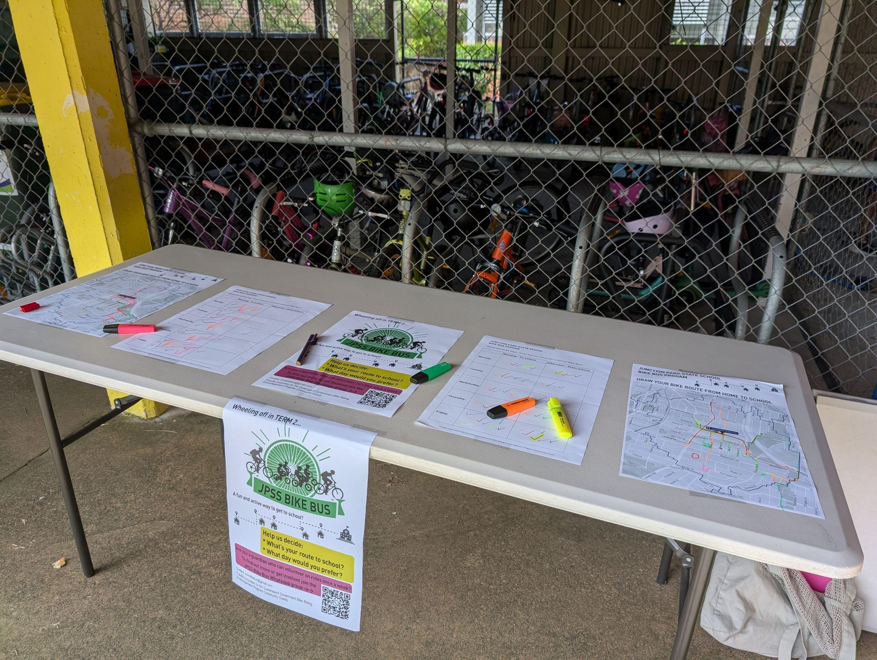

From there we hosted online workshops for each school (see Canva example lined below). We invited guests from a Canberra Bike Bus to speak; we heard all about their successes and challenges. The workshop also aimed to inform parents about what a Bike Bus was and address any safety concerns or questions. There were a number of common questions across all the schools which have formed the basis of FAQs for each school. We called for parent volunteers who were keen to lead a ride to school to help with the route planning / schedule setup. The workshop allowed us to hear about their riding experiences too.

The workshop presentation that was used for JPSS can be found here.

We set up Whatsapp Community groups for each school with channels for volunteers and riders etc. This would be the main communication channel when the Bike Buses were up and running.

With the key volunteers, we analysed the data (where riders and leaders live), we reviewed the potential routes and crossings in each area to try to determine the safest and easiest way to ride to school, while allowing the most children from the school catchment area to join the Bike Bus.

We decided on a Bike Bus schedule and timetable for each route in consultation with the route leaders. We planned a launch date for each school, staggering the starts so that we could support them as best as possible. There were some challenges while trying to plan around before school activities, something that is always changing.

We created promotional materials to advertise the Bike Bus routes and timetable too. We engaged with the school P&C associations and leadership to ensure they were across the plans and could help to promote the Bike Bus too. We put up signs around the school and advertised through the school P&C too. We found that word of mouth was also effective as families encouraged other families in their neighbourhood to ride.

After the bike bus routes kicked off we kept in touch with route leaders in case there were any tweaks to the timing or routes required. Enthusiastic route leaders were imperative to keep everything rolling smoothly. They would send a message out the night before the ride and check in to see who was planning to come etc. The Whatsapp community group was great for communicating to the bike bus families.

We kept weekly headcounts to keep track of route numbers too and how they may fluctuate over the term / year. We used an online spreadsheet to do this.

We asked for feedback from families part way into the school term to get feedback about any safety concerns on any of the routes. This could help to provide evidence for further active travel advocacy work by the schools. Towards the official end of the program we surveyed the parents involved for feedback about their experience with the bike bus. This will allow us to improve the program further with the support of the local school leadership and P&C associations too.

We created some other resources along the way to help any other groups interested in creating their own bike bus. They include:

- Initial survey (mentioned above)
- Workshop presentation survey (mentioned above)
- Leader training document
- FAQs for parents
- Headcount spreadsheet
- Safe active travel feedback

