Bike Bus Program - Active Travel Feedback

As the Bike Buses have been riding since the start of June, we wanted to get some feedback from leaders and parents / guardians about any points of concern (related to safety etc) on their route to school.

Yeronga State School Routes Feedback
Two routes: Corso Classic and Poinciana Peloton
Average riders per week, children: 11, adults: 9

Reasons for not currently riding to school (gathered from our initial survey):
- Have to cross Fairfield Road and there are also no footpaths where we live so we'd have to ride partially on the road.
- Concerned about riding near main roads
- Safety concerns x 3
- Dangerous roads
- Can only put youngest on trailer and don’t feel very safe having to ride on road

Safety and infrastructure related feedback has been compiled in the below map:
https://umap.openstreetmap.fr/en/map/yss-bike-bus-routes-feedback_1264562

Corresponding comments also documented here:
Brisbane Corso crossing near William Parade: Have to wait for a long time for a break in traffic before crossing safely. A pedestrian crossing would be ideal here.
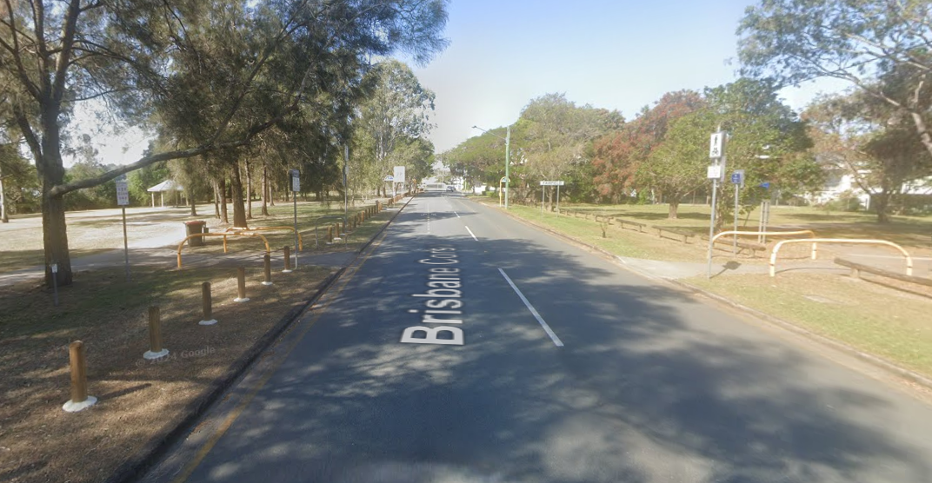

Intersection Fairfield Rd and Hyde Road: Riders have to cross two sets of lights here, the flow from the park to the other side of the road is not ideal. The south west curb at the lights is very small and steep, with not much room for bike riders.
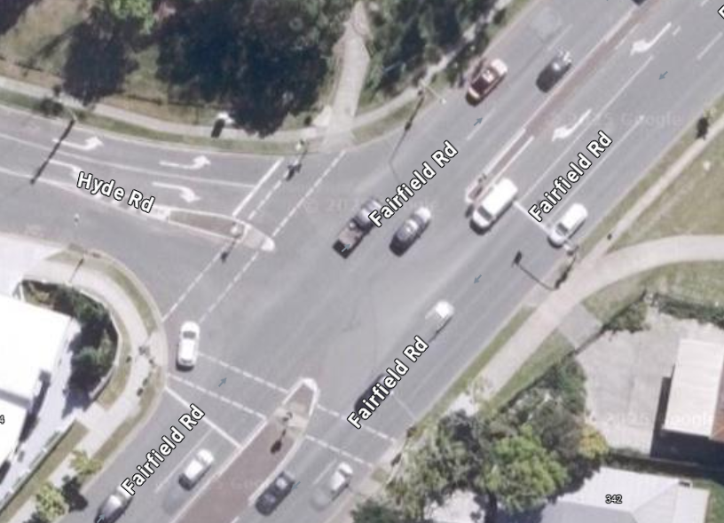
Zebra crossing on Park Rd north of Christensen St: Vehicles often don't stop at the pedestrian crossing in the afternoons after the crossing supervisor has gone.
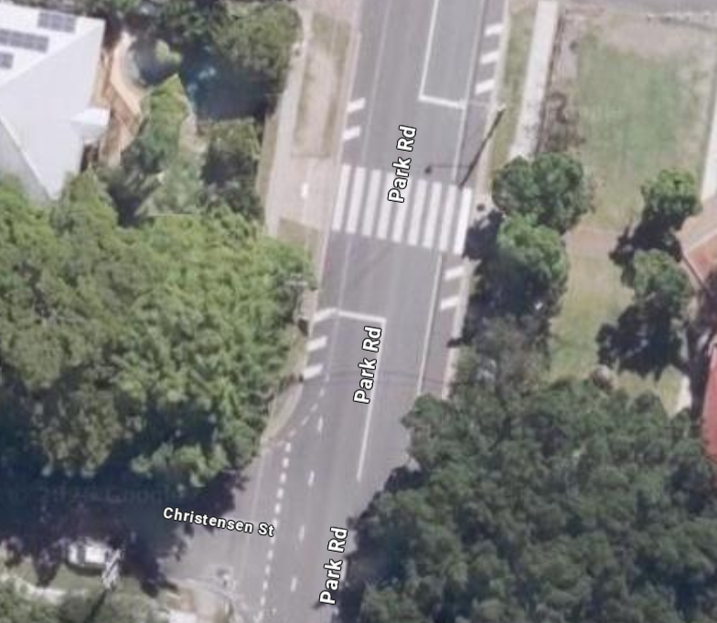

South St near Ipswich Road: The footpath on the south of South St suddenly stops here and riders have to cross the road to the other footpath. This is not safe as cars come around the corner quickly from Ipswich Rd and visibility is poor.
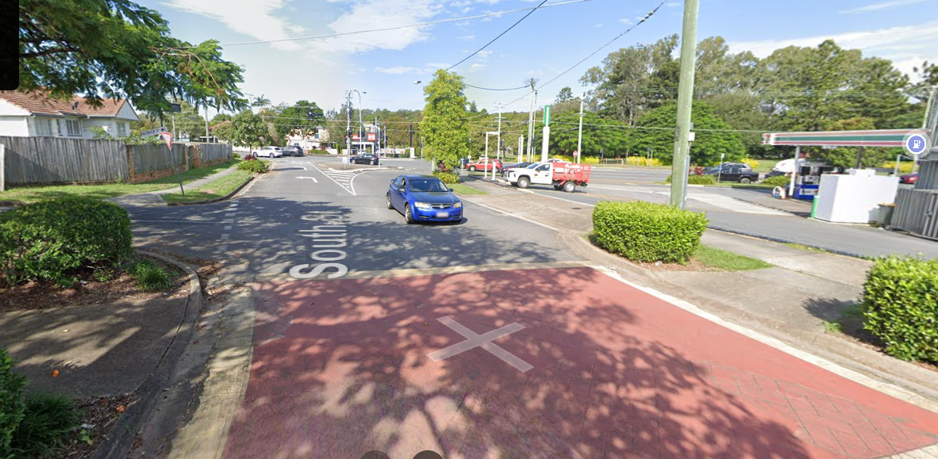

Additional safety concerns - Ipswich Rd and School Rd intersection (this is highly used but families of both the local school, kindergarten and pool too)
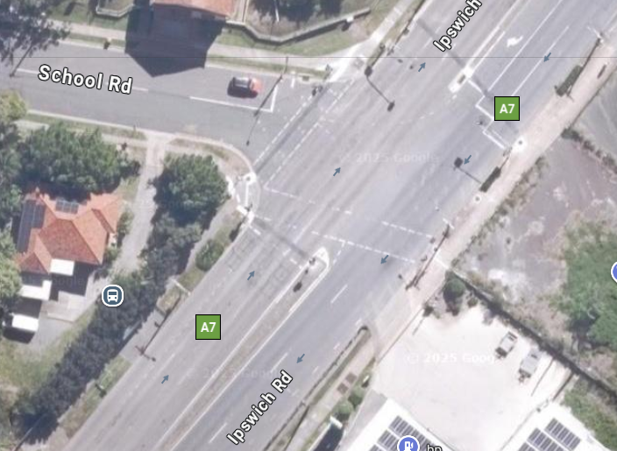

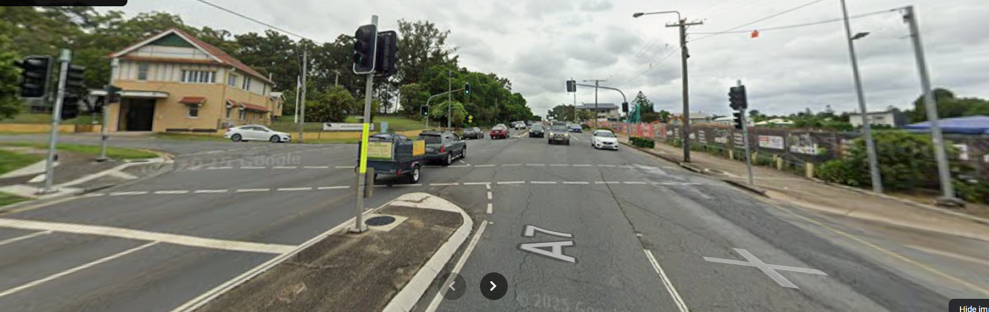

- Cars sometimes don’t stop at the northern traffic light and this is very risky for people crossing at the southern traffic light. A few families reported near misses here.
- Some cars come quite close / too fast while pedestrians are crossing
- Cars start inching forward when pedestrians are crossing (often due to seeing the green arrows but they are going straight)
- Cars turn into the service station abruptly, endangering pedestrians (there is frequently broken glass there indicating regular crashes)

Junction Park State School Routes Feedback

Three routes: Mt Cronin, King St Crit, Bower Bunnyhop.
Average riders per week, children: 18, adults: 10

Reasons for not currently riding to school (gathered from our initial survey):
- Too much traffic and no designated bike lanes. I do not trust the cars and e-scooters
- Other younger children coming with us and not safe as 1 adult with 3 small kids
- Busy road and uphill along Ipswich road
- busy traffic/dangerous roads
- Busy roads to cross

Safety and infrastructure related feedback has been compiled in the below map:
https://umap.openstreetmap.fr/en/map/jpss-bike-bus-routes-feedback_1264572

Corresponding comments also documented here:

Intersection Junction Terrace and King St: Motorists come zooming down the hill on Junction Terrace very quickly (despite the speed bump), there are lots of families that park around this Junction to accompany kids to school. Having a 40km/h school zone here would make a huge difference.
Cars come flying into King St (down the hill on Junction Tce), often on the wrong side of the road due to parked cars.
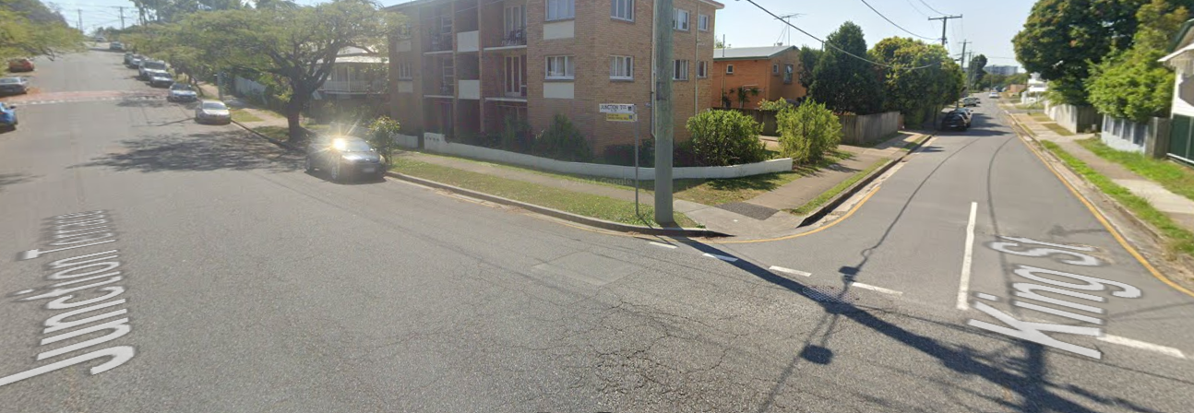

There were a number of issues reported around the junction of Fanny St, Annerley Road and Ipswich Road. This is a very busy area with cars and pedestrians / cyclists alike.

Traffic light crossing of Annerley Road: Crossing time is inadequate, not long enough for kids / riders to get across.
Traffic light crossing of Ipswich Road: Crossing only gives you 5 seconds of green person before it goes to countdown mode. Very inadequate for most people, esp those walking.

Motorists turning from Ipswich into Annerley Rd often don't notice it's a separate set of lights and just go through the red light. The turn goes from a 50 km/h limit to 60, and so cars start speeding up exactly at this point, making it extra scary with the indicating left confusion.

Fanny St crossing is concerning because it is so wide and it is hard to tell if cars, who are indicating off Ipswich Rd into Annerley Rd, are actually going to turn into Fanny St (some don't indicate either!)
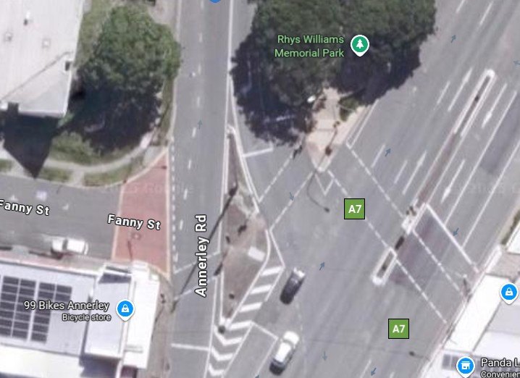
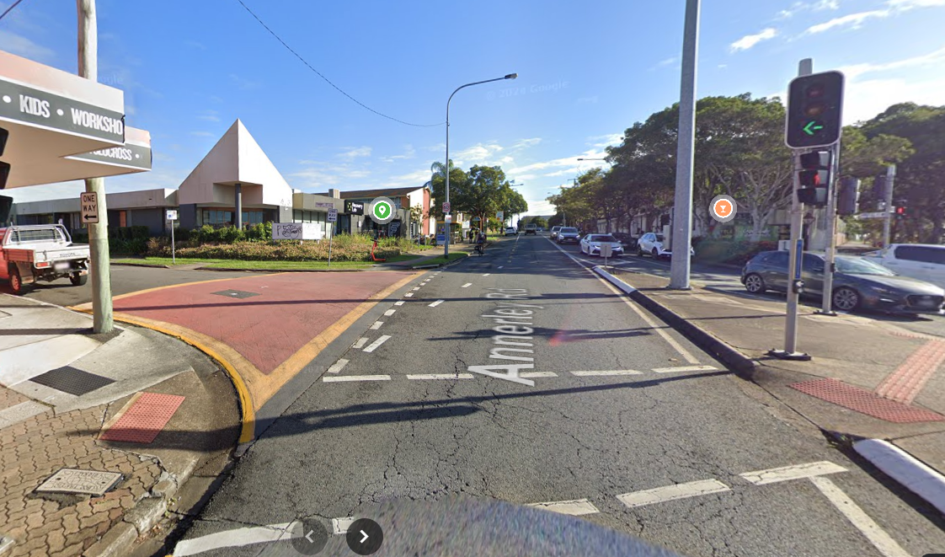

Crossing Ekibin Road at Bower St:
Busy road at peak hours before school and designated crossing is down near Gustavson St - too far to detour for kids.
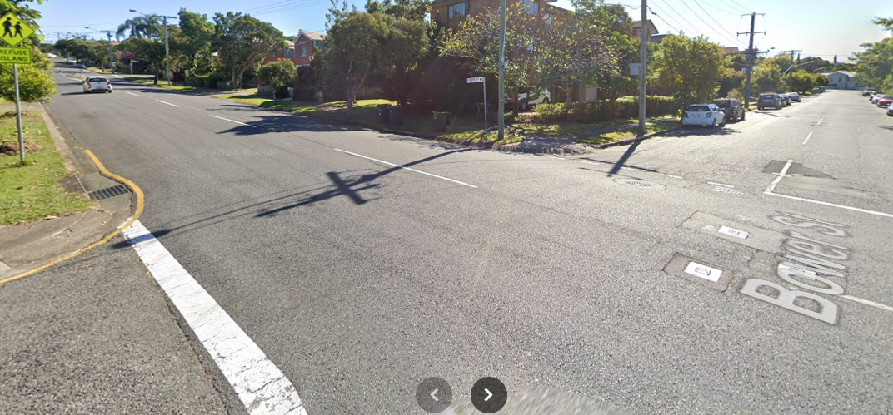

Crossing Waterton Street at Bower St:
Busy road at peak hours before school and designated crossing on Waterton St is right up at Ipswich Rd - too far to detour.

These two crossings are far from the signalised crossings, but these locations are logical in supporting students on bike bus and non-bike bus days as they are central crossing points from the southern catchment to the school.

Crossing Ekibin Road East Near Gilmore St:
The road is so dangerous to cross at certain times of day and going up to the roundabout or down to the lights is a long way to cross the road.

