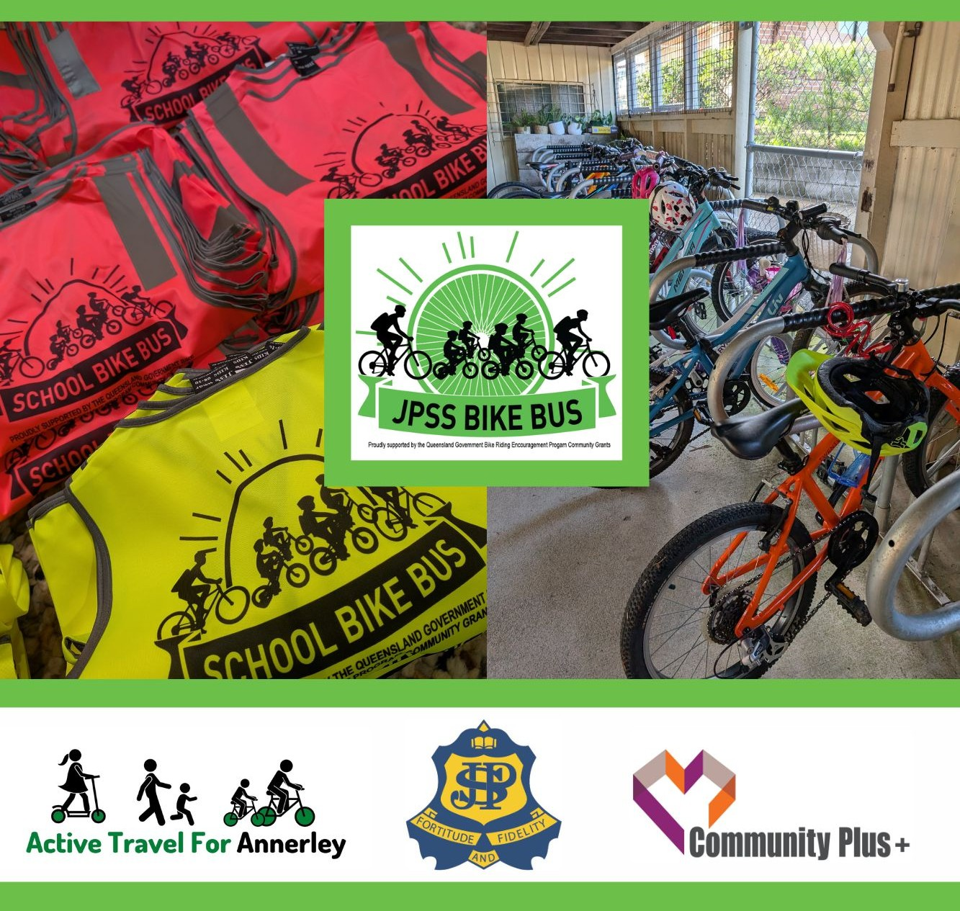
JPSS Bike Bus - Everything You Need to Know
What is a bike bus?
A bike bus is a group of people (children and parents/guardians) who cycle to school together. It’s called a “bus” only because there is a fixed route and schedule. It’s a fun, active and safe way to get to school.
The bike bus will keep evolving and grow as we go, so we need your support, feedback and enthusiasm.
We recommend that all kids turn up with a parent for at least the first week. Then if they are old enough (and they would be making the ride on their own to school anyway) we're happy to take them alone in the following weeks. It's also nice for the adults to meet other families in your neighbourhood too. It's not essential that you tell us that you're coming on the Bike Bus but it will help the ride leaders if you do.

Bike Bus Timetable & Route
The community-run Bike Bus runs every Wednesday morning.
Volunteers lead three different routes, covering almost the whole school catchment, starting around 8am and arriving at school at 8.25am. Kids drop bikes at the bike cage, then volunteers provide some snacks in front of the Library.
Routes follow quiet, wider streets, and avoid long hill climbs. They roll along at a slow pace, with lots of time for chatting. Adults help the kids across any busy streets.
The Bike Bus is led by school parents and local volunteers from Active Travel for Annerley.
Below are the three routes and timetables.
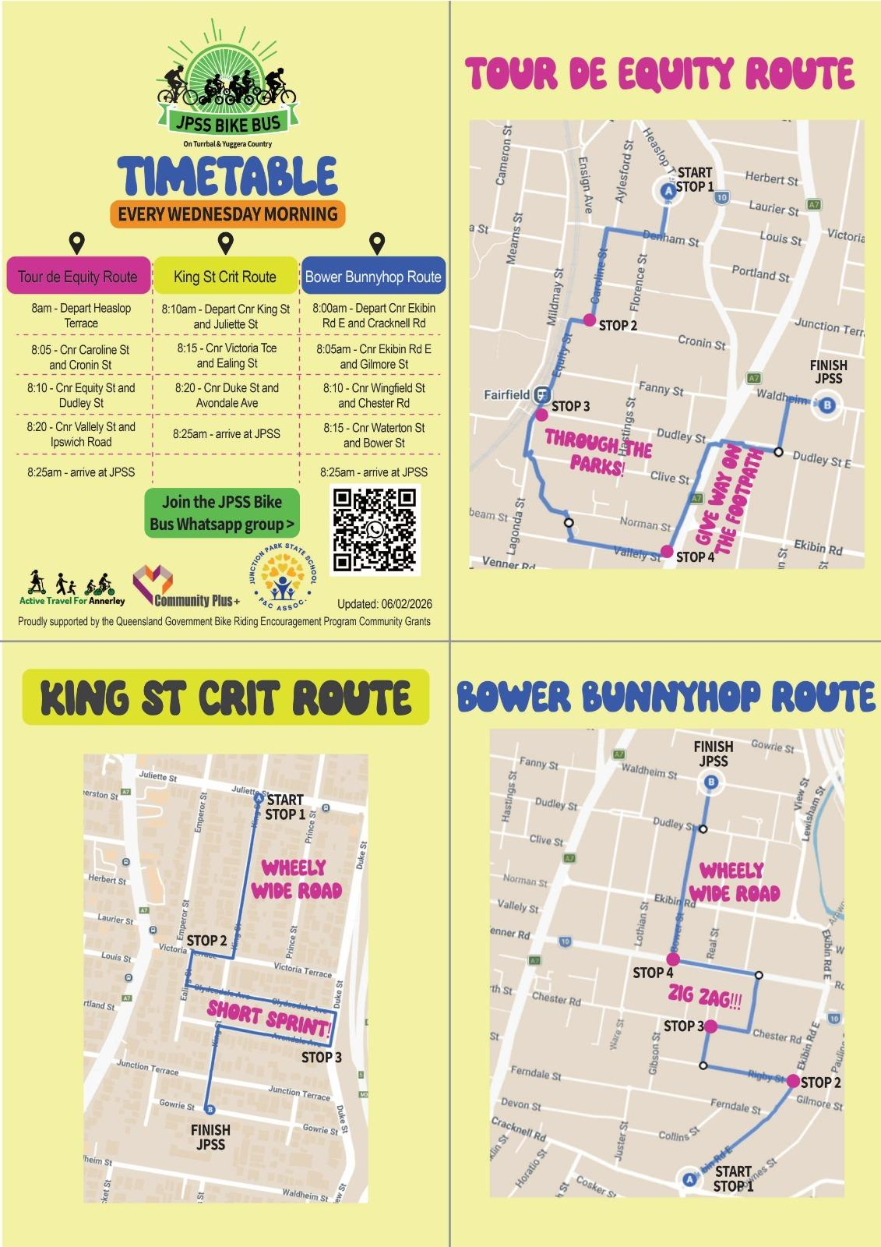
JPSS Bike Bus Map
Come ride with us!
To join up you can:
- Join the WhatsApp Community here
- Come say hi outside the Library at 8.30am any Wednesday
- Or just roll up to the start or any of the listed stops on a Wednesday

FAQS
Can scooters come too?
We’re happy to include scooter riders with us, they must wear a helmet and be comfortable keeping up with the pace of the group and distance of the journey to school.
Do I need to ride with my child?
We recommend an adult / guardian riding with each child (especially at the beginning of joining the bike bus). An adult / guardian may be accompanying a couple of children and perhaps also children from another family they are friends with.
If your child is older and would usually be riding or walking by themselves then we just require you to let us know via the Whatsapp group they’ll be joining the bike bus alone (but adults should come along and meet some other neighbourhood families if you can!)
If you are keen to help lead a ride please get in touch via Whatsapp.
Is this for OSHC kids?
Unfortunately due to the timing the Bike Bus won’t cater for children going to OSHC before school. We will depart the first stop on the route around 8:00am, arrive at school by 8:25am and then enjoy a healthy snack together.
What do I need for my child to join?
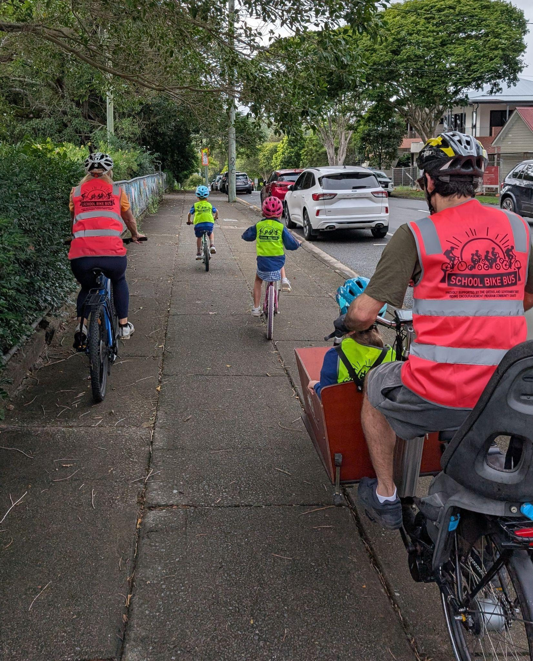
- Working bike (A - air in tyres, B - brakes are working, C - chain is in good working condition)
- Correct fitting helmet
- Working bell
- Bike lock (optional) as bike cage is locked/unlocked during the day by school staff
Safety
Kids will get a high vis vest to wear on the bike bus. Leaders will have high vis vests too along with a safety flag and some music to keep the group entertained. We will ride on footpaths and where safe we will ride on quieter roads as a group. We will have adults at the front and back of the group.
What if it’s raining?
We’re likely to proceed with the bike bus in light rain. If the bike bus is cancelled for any reason this would be communicated via the Whatsapp Group on the morning of the ride.

